
Create A Website That Makes You Money
To get your website right now go to IncomeActivator.com.
You can begin NOW and refer to this book as you go or keep reading.




Income Activator tells you how to make money online through your own personal recommendations, and gives you a ‘ready to go’ website to make it happen!

Your Opinion Has A Market Value

Making money online ‘By Telling People Where To Go’ is a dream come true for many of us.
Through your own experience you can be paid for giving advice. You may even become an authority that people go to get the best information or advice. You can have people flocking to your website to see which companies offer the best services or who to buy from.
You do it every day. You may recommend the best painter to use, which lawyer or accountant to go to, or where to get the best deals on whatever. But you never get paid for it. Now you can.

Who Benefits
Internet Marketers - You now have complete control over your website. No webmasters or add on programs necessary.
Newbies - You can create a website that makes you money online even if you’re a one finger typist.
Website Owners – You can instantly activate additional revenue streams on your own website today.
Parents & Students - You can operate your own business on your own schedule, and make money online without selling a thing.
Jobless & Seniors - Easy step by step videos show you how you can share your knowledge with the world and get paid for it.
Artists & Musicians & Trades People - Display your talents, while earning referral revenue. Selling your stuff is a bonus.
Social Media Addicts - Simply apply everything you’re doing right now to this program and you’ll make a shocking amount of money.
The Shy - You can begin to make money online right now without ever having to talk to anyone.
Computer & Internet Illiterate – Being unencumbered by knowledge allows you to get it right the first time. You have a ready to go website to begin generating revenue right now.

You Tell People Where To Go… All The Time… Now Get Paid For It Online.
You can package your knowledge on any topic, in any industry, and be paid by companies for referring people to them.
It works like this. Imagine an accounting firm paid you $40 every time you recommended them. The Internet allows you to get paid just like that for your recommendations, Big Time!
Sending leads to companies that pay you is a truly wonderful way of making money online. People and companies around the world are using this business model to make money right now. It’s not a secret formula, and it’s easy to implement. This book tells you how it works and you get the website to make it happen.
.
Your Website Features

You have a ready to go website that includes:
Unlimited Website & Mobile Pages
Pictures & Videos & Links
Search Engine Optimization
Forms & Surveys & Data Collection
Auto-Responders & Unlimited Email Messaging
Visitor Commenting & Member’s Sections
Online Store & eBook & Product Creation
Social Networks & RSS Feeds
Marketing Strategies
Proprietary Pay Per Click & Referral Programs
You can create pages and forms simply by typing in want you want, or you can work in HTML. You can add pictures, links and videos with the click of your mouse. The marketing section of your website program steps you through the process of creating a website that makes you money with ‘how to’ videos and screenshots

. Table Of Comments

Chapter 1 The Formula to Making Money Online …….... Page 4 ________________________________________________________
Chapter 2 Be Paid By Telling People Where To Go …..…Page 8
Google Pay Per Click Revenue.....………........ Page 9
Income Activator Pay Per Click Revenue…... Page 18
Referral Revenue From Leads…….………….. Page 20
Directory Referral Revenue………………….... Page 25
Affiliate Revenue………………..……..………... Page 30
Income Activator Affiliate Revenue……......... Page 34 ________________________________________________________
Chapter 3 Referral Revenue Verses Sales Revenue…... Page 36
________________________________________________________
Chapter 4 Follow Your Passion…………..……………...... Page 44 _______________________________________________________
Chapter 5 Identify The Keywords Being Searched….... Page 50
Where To Find Advertisers……..………….… Page 59
________________________________________________________
Chapter 6 Content Is King………………….…………….… Page 68 ________________________________________________________
Chapter 7 Your Website Set Up……………………....…... Page 80
Hosting……...................................................... Page 91
Choosing You Domain Name…….………….. Page 92
How To Get Your Website……………….……. Page 102

…….. Chapter 1


The Formula to Making Money Online

Send Leads

To Companies

That Pay You
Here’s how the formula for making money online works;
1. Identify the keywords people are using for online searches.
2. Create content related to those keywords.
3. Make money by sending visitors to companies that pay you.
If you have more pages, you get more traffic. If you have more traffic, you make more money.
Content Websites – THAT’S IT!

This is responsible for generating BILLIONS of dollars on the web right now. And this business model is never going away!
The entire Internet is made up of CONTENT. There will always be a NEED for content and therefore always a way to make money from it.
Call it Virtual Real Estate, Content Websites, or Authority Websites.
Whatever you want to label it, it's what makes the entire Internet work.

This Is A HUGE Opportunity For You To Build A Business Around
You might already be making money from it as thousands of people are. But if you aren't, or you want to greatly grow what you're already doing then you’ll need to consider having a website incorporating Referral Revenue Streams.


Identify The Keywords People Are Using For Online Searches
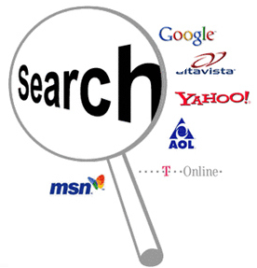
New websites are being created every day that end up ranking #1 on the search engines for their search terms, also known as keyword phrases.
When you identify and target your website to a specific search term, your website will be indexed by the search engines for that keyword phrase, and displayed to people doing online searches.

Search engines need people to create websites to be included in their index. That's how they exist. There are 100’s of search engines, such as; Google, Yahoo and Bing displaying websites to people doing online searches.

Create Content Related To Those Keywords

When you identify the main keyword phrase people are searching for that applies to what your website’s about, you create content related to those keywords.
You target certain keywords and create original content around those keywords.
The key here is GOOD content, not garbage.
Make Money By Sending Your Visitors To Companies That Pay


Big companies build their entire business around this simple 3 step process of identifying the keywords people are searching for, create content related to those keywords, and monetize their pages with company pay models.
They make money from pay per click links, referral forms, and affiliate links.
More Pages, More Traffic, More Money

If you have more pages, you get more traffic. If you have more traffic, you make more money. It’s the ABCs of Internet marketing.
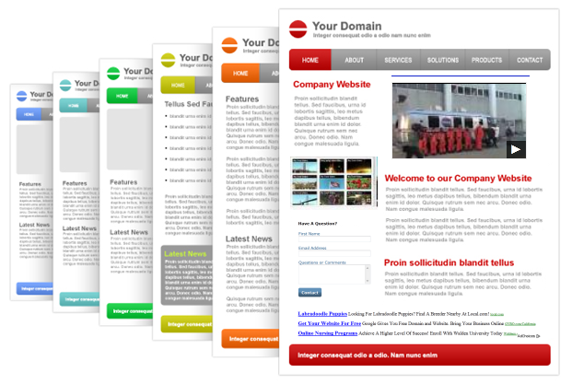
A. If you have more pages, then you have more content that gets indexed.
B. If you have more content that gets indexed, then you get more search traffic.
C. If you get more search traffic you make more money.
That's it. It's Not Rocket Science.
Then WASH, RINSE & REPEAT Every Day

Search engines visit websites that are updated regularly and index their pages to be displayed for online searches ahead of websites that are rarely updated.

This Business Model Is Never Going Away
If you want to build a rock-solid, long-term business online then build a content website where you send your visitors to companies that pay you for your leads.
In 10 years from now you'll be reading an article about what makes money online and content websites which send visitors to companies that pay you for your leads will still be one of the greatest ways to do it.
Earning Potential

Leads are used by businesses all the time, but people either ignore it or just don't understand it enough to realize how TRULY GREAT leads really are.

Every BIG Company Was Once A Small Company
Take these 3 companies for instance;
1. DEMAND MEDIA - They went public and are now worth $2 Billion.
2. ASSOCIATED CONTENT - Yahoo bought them for $100 Million.
3. HUFFINGTON POST - AOL bought them for $315 Million.
What do all of these big money companies have in common?
They're all using the same business model that YOU can use too.


Hi, I'm Lee Romanov. In 1995, I began making money online by sending leads to companies that paid me. I created a comparison guide for insurance rates called InsuranceHotline.com, and made millions of dollars throughout the years. I was approached by Torstar, one of Canada's largest media corporations who bought my business and paid me handsomely for it.
After the sale, I created a website builder called Income Activator and incorporated all the revenue programs I used to make money online. Now, it’s available to you,
Like all of us wanting financial security, and a better life, I had also turned to books like; 'Think And Grow Rich' and ‘The Secret'. What I discovered is that these books only gave you half the formula to becoming financially secure and how to achieve a better life.

